Multivariable Control Course 1 – State Space Model

# Exercise 1

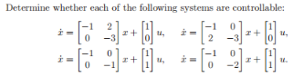

## 1.

We have to find the controllability matrix: in these for cases the controllability matrix, will have this form.

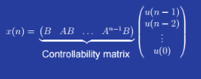

Where n is the number of states.

So in this case, the controllability matrix will look like:

It is not full rank since the determinant is 0, and it is therefore not controllable.

## 2.

It is not controllable.

## 3.

It is full rank since the determinant is not zero it is thereby controllable.

## 4.

The determinant is not zero, it is therefore not full rank and the system is thereby controllable.

# Exercise 2

# 

## 1.

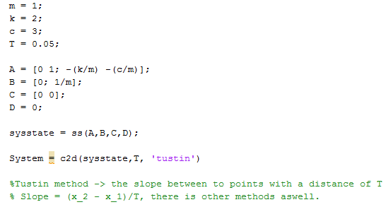

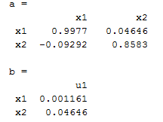

## 2.

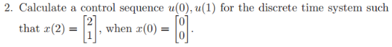

Two equations with two unknowns:

Verify:

*The u(0) and u(1) is thereby correct*

## 3.



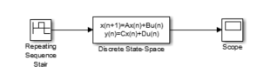

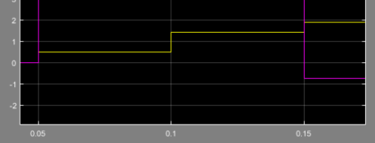

# Exercise 3

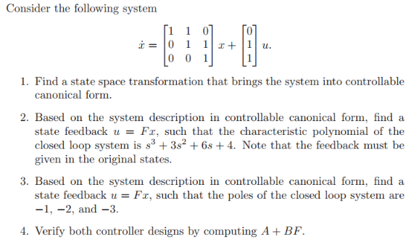

## 1.

Is it controllable?

It is controllable

Canonical form for

Canonical form for :

## 3.



Desired system characteristic polynomial

Now we make a characteristic polynomial from the found canonical form.

See the canonical form and use the nice rule that:

This is for a 3 times 3 matrix

We need to go back from canonical form.

## 4